YOU CAN DO IT!
ULTRA BEGINNING TENNIS

The class consists of EASY TO DO learning steps, from David’s book “8 weeks to a Lifetime of Tennis” that produces an ability to practice alone or with new friends you have made. All students go on to call TENNIS their new sport within the first day. All students learn easy to replicate hitting on a wall. No STRESS to learn.
Monday Sessions:
- June 5th-26th (No need to attend all classes to be included)
- July 3rd -24th
- Aug. 7th-28th
Monday evenings 6p-7p $99 for whole session or $25 per class
Saturday Sessions:
- June 3rd-24th (No need to attend all classes to be included)
- July 1st-22nd
- July 29th-Aug. 19th
Saturday Mornings 9a-10a $99 for whole session or $25 per class

Come learn the EASY WAY and make new friends that immediately want to practice and rally with you. Come to 1 class or all 4, it’s up to you!! YOU WON’T even need to bring your own RACQUET. We have that covered.

Contact David Archer davidslcman@gmail or by texting 530.864.4255

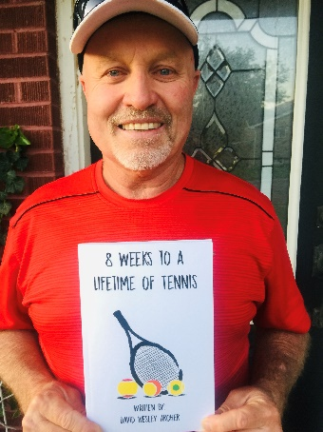
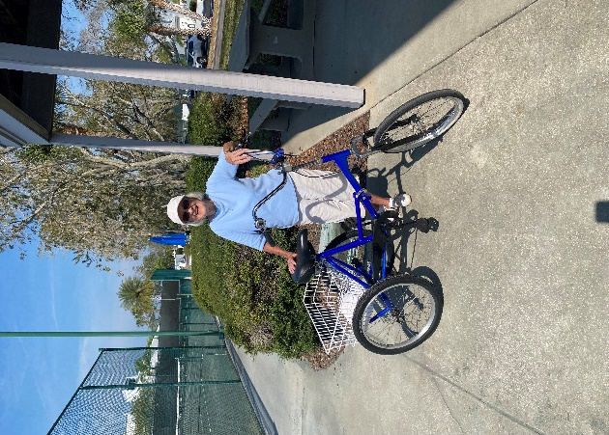
Don’t miss out on this opportunity to learn the sport of tennis from author David Archer and be a part of the Shipwatch Tennis Community.

